Public Pension Coordinating Council

Public Pension Standards Award
For Funding and Administration

2009

Presented to

City of Sunrise Police Officers’ Retirement Plan

In recognition of meeting professional standards for
plan funding and administration as
set forth in the Public Pension Standards.

Presented by the Public Pension Coordinating Council, a confederation of

National Association of State Retirement Administrators (NASRA)
National Conference on Public Employee Retirement Systems (NCPERS)
National Council on Teacher Retirement (NCTR)

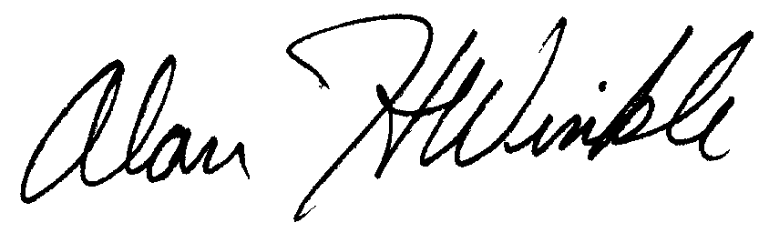
Alan H. Winkle
Program Administrator

